Football kit

Salters’ School have a new football kit.
Blue shirt and white shorts.
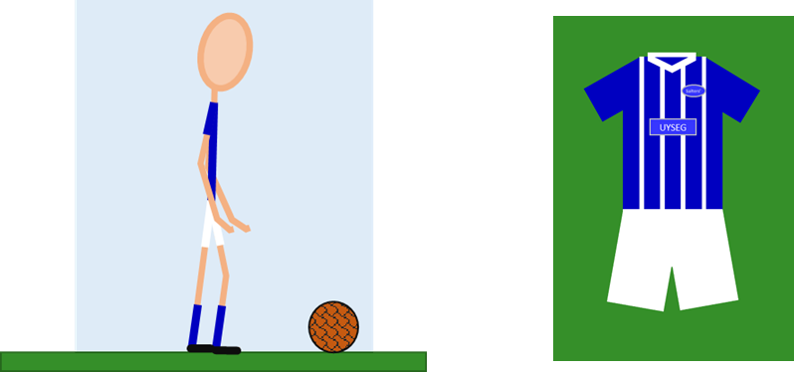

Why do you think the football kit looks blue and white?
Which of these statements do you think are right?
For each statement, tick (✓) one column to show what you think.
Statements |  | I am sure this is right | I think this is right | I think this is wrong | I am sure this is wrong
A | Blue light reflects off the blue shirt
B | The shirt makes the light turn blue
C | Blue light reflects off the white shorts

Physics > Big idea PSL: Sound, light and waves > Topic PSL2: How we see > Key concept PSL2.2: Seeing in colour
Diagnostic question
Football kit

Overview
Learning focus: | Light has colours that are seen when reflected by bodies.
Observable learning outcome: | Describe how coloured objects selectively reflect particular colours in white light.
Question type: | Confidence grid
Key words: | White light, reflect

What does the research say?
To understand why objects look the colour they do students need first to understand the scientific explanation of how we see non-luminous objects that are considered in the key concept: PSL2.1 The ‘passive eye model’ of vision.
In a study of 13-year-olds (n=150), 72% did not think that white light was a mixture of different colours (Zylbersztajn and Watts, 1982; Driver et al., 1994). For a physicist, sunlight and daylight are both examples of white light. Each consists of all the colours of the spectrum which combine to be seen as white. Students often regard white light as ‘pure light’ that is free of any tinge. More than half of a sample of 13- to 16-year-olds (n=166) considered colour to be different to light and something that is added to light (Galili and Hazan, 2000). This idea was covered earlier in this key concept.
This question investigates what students understand about how coloured objects selectively reflect particular colours in white light.
Ways to use this question
Students should complete the confidence grid individually. This could be a pencil and paper exercise, or you could use an electronic ‘voting system’ or mini white boards and the PowerPoint presentation.
If there is a range of answers, you may choose to respond through structured class discussion. Ask one student to explain why they gave the answer they did; ask another student to explain why they agree with them; ask another to explain why they disagree, and so on. This sort of discussion gives students the opportunity to explore their thinking and for you to really understand their learning needs.
Differentiation
You may choose to read the questions to the class, so that everyone can focus on the science. In some situations it may be more appropriate for a teaching assistant to read for one or two students.
Expected answers
A and C are correct and B is wrong.
How to respond - what next?
White light is made up of all the colours of the spectrum. The blue light in white light can be seen if it reflects off the blue shirt into the eye (the other colours are absorbed by the shirt).
All of the colours of light reflect off the white shorts and blue is one of these colours. All of the other colours reflect off the white shorts as well. All of the colours combine to make white.
Answer B indicates the student imagines that the blue shirt adds something to the light, or changes it in some way.
If students have misunderstandings about how coloured objects are seen in white light, it can help remind them that white light is made from a combination of all the colours of the spectrum. Following a discussion of how coloured objects reflect just some of the colours in white light, students could be given the opportunity to illustrate what happens with a labelled diagram. It can help for students to work in pairs or small groups, which encourage social construction of new ideas through dialogue.
Acknowledgments
Developed by Peter Fairhurst (UYSEG).
Images: Peter Fairhurst (UYSEG).
References
Driver, R., et al. (1994). Making Sense of Secondary Science: Research into Children's Ideas, London, UK: Routledge.
Galili, I. and Hazan, A. (2000). Learners' knowledge in optics: interpretation, structure and analysis. International Journal of Science Education, 22(1), 57-88.
Guesne, E. (1985). Light. In Driver, R., Guesne, E. & Tiberghien, A. (eds.) Children's Ideas in Science. Milton Keynes: Open University Press.
Zylbersztajn, A. and Watts, D. M. (1982). Throwing some light onto colour. Guildford: Mimeograph, University of Surrey.

